# DIANE KELBER



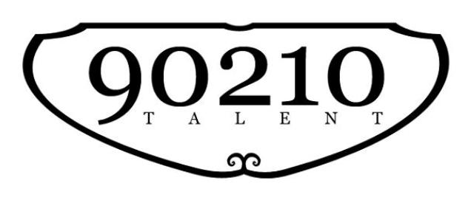

**818.928.5717**

**SAG-Aftra/AEA**

[*www.dianekelber.com*](http://www.dianekelber.com)

[dianek123@me.com](mailto:dianek123@me.com)

Height: 5' 4” Hair: Salt & Pepper

Weight: 100 Eyes: Hazel

Lisa Gal (O) 424-389-0008

(C) 818-445-9243

## FILM

Endings, Beginnings (Shailene Woodley) Gretchen (Supporting) Drake Doremus/feature

Go Ah (2023) Eloise (Star) Tony Sears (short)

Marriage Material Volunteer (Supporting Lead) Oran Zegman/Fox Searchlight

Music (2021 Kate Hudson) Featured Dancer Sia/feature/IMAX

Florence (2020) *Best Actress - 3 Florence (Star) Emanuele Daga/AFI thesis

Lifetime (2022 short) Liz (Supporting Lead) Kaleb Cruzado (USC)

Vibrations Ballet Teacher (co-lead) Bella Issa/AFI thesis short

48-Hour Film Festival (“Roses”) Supporting Producer’s Guild/Short

The Path Lead Tony Sears/Short

The Equation Lead Jonathan Bernbaum/USC

Wind in the Grass Lead Yasuhiko Tanaka/indie short

Doubles Supporting Jacob Motz/indie short

No Hitter Supporting Julius Robins/USC

Rent Tenement Dancer Chris Columbus/Feature

**TELEVISION**

The Patient (10/2022 Steve Carell) Recurring CoStar (Denise Benjamin) FX/Disney, Chris Long

Web of Make Believe (6/22) Supporting (Wendy Gregory) Netflix/Ron Howard/Knappenberger

Stars in the House Host (w/guest Sandy Duncan) Seth Rudetsky/James Wesley

Ladies of the Law Guest Star (Judge) Dan Garcia/UMC

Weeds (final season) Guest Star (Dr. Galante) Perry Lang/Showtime

Ground Rules Self HGTV/Reality

**THEATRE/STAGE (partial list)**

A Christmas Memory Sook (lead) Sierra Madre Playhouse

To Kill a Mockingbird Miss Maudie/Narrator (lead) Sierra Madre Playhouse

Blue Grass (original 1-act) Sarah (lead) Interact Theatre and Theatre in J

Two Peas in a Pod (original solo show) Directed by Darryl Hickman The Bitter Truth Playhouse

Roar of the Greasepaint. . . The Kid Sacramento Theatre Company

Not in Earnest! Miss Prism Lionstar Theatre

No, No, Nanette (w/ Nanette Fabray) Winnie Long Beach Civic Light Opera

South Pacific (w/ Sandy Duncan) Dinah Long Beach Civic Light Opera

Company (w/ Carol Burnett) The Vocal Minority Long Beach Civic Light Opera

State Fair (premiere) Featured ensemble Broadway Preview, N. Carolina

Annie Grace Farrell Petrucci's

Guys and Dolls Sarah Brown Shalimar Theatre

Most Happy Fella Rosabella Whitemarsh Theatre

Quilters Janie, Molly, Harriet, Nurse, et al Castle Theatre, Washington, D.C.

Cincinnati Opera, MDT, Philadanco Corps de Ballet/Principal Dancer Cincinnati, Maryland, Philly, Tour

**TRAINING**

*Improv* Upright Citizen’s Brigade UCB Theatre, 101

*Cold Reading, Scene Study* Katt Shea & Darryl Hickman On camera and Studio

*Commercial* Killian’s Commercial Workshop Killian McHugh

*Voice Over* Commercials, Narration, etc. Don LaFontaine VO Lab

*Singing/Musical Theatre* American Center for Music Theatre Faith Rumer, Joanna Gleason etc

**SPECIAL SKILLS**

Ballet teacher, Former Pro Dancer, BA/Dance-UCIrvine, Swimmer, Yoga, Pilates, Pro Singer/Coloratura, Basic Spanish